the madison minutes
  - February 2022
highlights
- Mr. Fix-It
- Amazing Audra
- Sensational Shelly
- Even-Keeled Eberle

Holden Grandstaff, Administrator
hgrandstaff@themadison.biz
Dawn Fullhart, Asst. Administrator
dfullhart@themadison.biz
Rebecca Newton, DON
rnewton@themadison.biz
Kathy Casey, Social Services
kcasey@themadison.biz

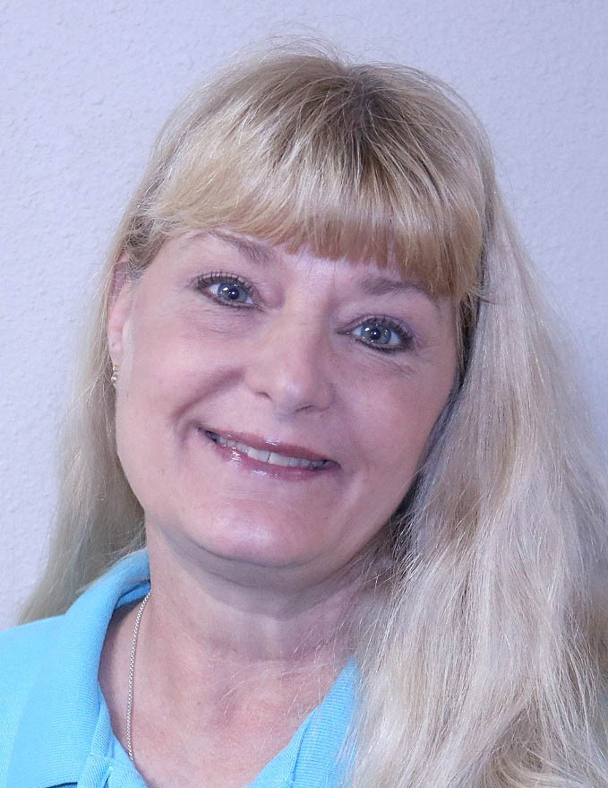
Audra Bonar, Administrative Assistant

he’s better than fix-it felix, he’s fix-it earl
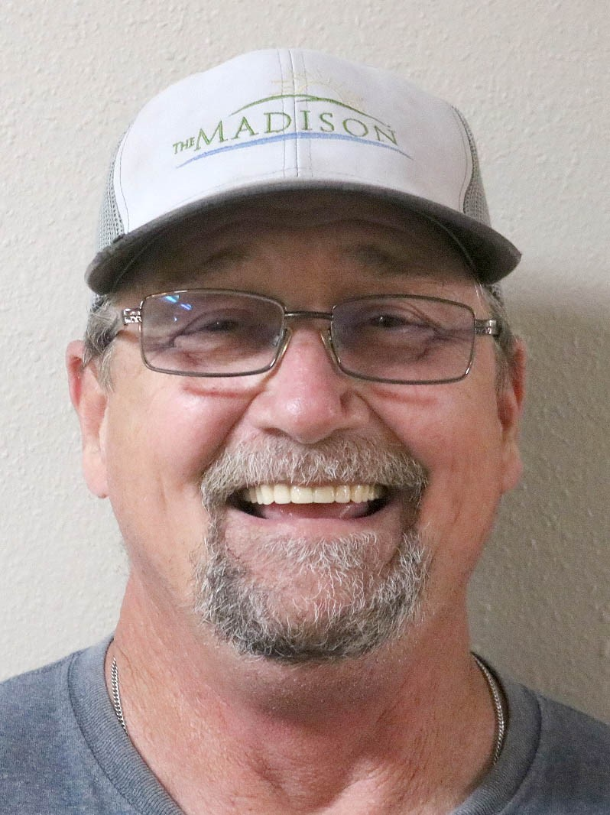 What can I say about Earl? Well, if you ever want to know a guy that doesn’t have a smile, or a greeting and any substance filled conversation then don’t bother meeting our maintenance man at The Madison. Earl has that personality and demeanor that is infectious and just makes you want to have a good day when maybe the day hasn’t started as planned. Throughout the halls you can hear his laugh, which is one of the most distinct laughs I have ever heard (in a good way). I mean look at his picture and you just know this guy enjoys his job, co-workers, and most of all the residents.
In total, Earl has been in maintenance at The Madison for 23 years. He started in delivery of laundry to another facility and did maintenance for three years in a facility before becoming full-time at our facility. He loves working with the residents and staff.
Earl is a father of 2, grandfather of 3 and great grandfather of 2. He loves to travel to Florida and Branson in his free time to visit his brother in Florida. Camping is an escape for him and his wife in their motorhome, but no fishing because Earl doesn’t do that. He likes to attend car shows and enjoys watching NASCAR. Earl is heading into retirement at the end of this year and The Madison Senior Living will miss the upkeep of our facility, but most of all that distinct laugh and infectious smile that everyone wants to have in their lives.
____________________________________________________________
"I came to The Madison for rehab because of a knee replacement. The physical rehab team has me walking and pushes me on the stairs, and is knowledgeable while being polite. CNAs are great. Food is better than the last place I did rehab for a knee replacement. It's difficult to match food for every palate, but The Madison does a great job. I would give the facility a 5-star and recommend The Madison for physical rehab." -Joe, resident
____________________________________________________________

the madison, this is audra
When you call into The Madison, you probably hear the calm and caring voice of Audra. She has a demeanor that is delightful and is always able to answer a question or find a solution. But Audra is more than just a voice on the other end of the line, she is a major cog in the wheel that makes the business aspects of healthcare turn.
Audra has a unique story of why she calls The Madison her family. Her story begins with her father’s diagnose of Alzheimer’s in 2018. She spent a considerable amount of time helping her father work through changes in his life and fell in love with the staff and residents, immediately. She has a lot of respect and gratitude for the nursing and staff who took care of him. At that time, the receptionist was talking about retirement in 2019 and talked her into applying for the receptionist opening. Audra’s current job as Administrative Assistant is one of many hats that includes human resources, payroll, and supply management which means paper, paper, paper and trying to keep her Administrator and Supervisors in line! (LOL). She has seen a lot of changes in this building, loved and lost residents and watched employees come and go. Through it all, she is grateful for our family here at The Madison and we are so appreciative of her.

ACTIVITIES ABOUND FOR ALL 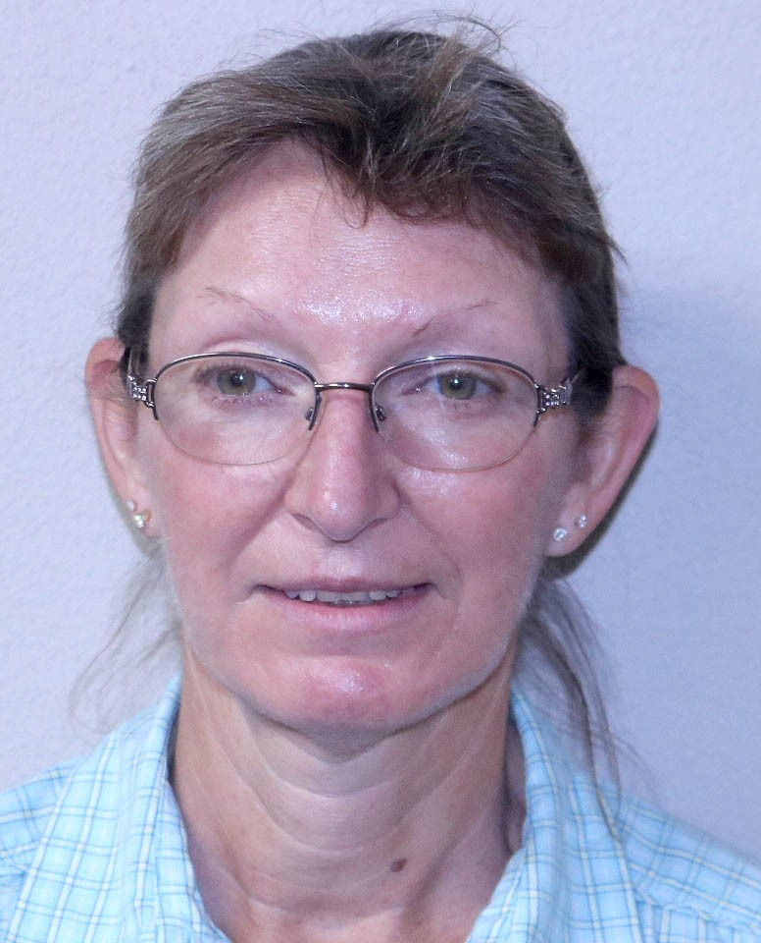
Shelly Gregory, Activities Coordinator
What do activities at The Madison have to consist of per the guidelines set by long term care governance? Activities must include spiritual, intellectual, recreational, and physical activities. There is also a component of community activities both inside and outside the facility like having music or other entertainment into the building for residents to enjoy, and outside the facility like handing out candy to kids at Halloween or other events within the community. A lot goes into planning and then implementing these activities, and Shelly Gregory has done it well and to perfection for going on 13 years. Being the Activities Coordinator, Shelly can bring smiles to resident faces, and that is what she says is her favorite part of the job, SMILES.
In total, Shelly has been a part of The Madison Senior Living family for 34 years, took some time off for a short stint, and then came back for her second stint in 1995 for 26 years rolling strong to present. She has held roles and been certified as a CNA, Bath Aide, Med Aide and holds her CDL license for transportation. Shelly became a certified as an Activities Coordinator in 2009 and graduated from college in 2013 with a degree of Administrative Assistant in Business Administration.
Shelly can’t work all the time, although the residents would love her to, she does have a life outside the facility. She enjoys gardening, just being outside camping, riding in her Kubota side by side, and most of all, enjoying time with her grandkids. Thank you, Shelly, for your years of service and for the smiles you have brought to hundreds of residents over the years.
EVEN KEELED EBERLE
Let me tell you about a resident who is mild mannered and always a pleasure to be around. He greets you with a hello in the mornings as you walk into the halls and dining room and strikes up a conversation about how your day is going. The staff and other residents enjoy his company and speak highly of him. Who is this resident? Mike Eberle! As the headline reads, he is even keeled and everything about Eberle is a joy. But let me tell you more about him and who he was prior to coming to reside at The Madison.
Born in 1940 Detroit, Mike lived there for 50 years and raised two kids. He is a 1963 graduate of the University of Detroit with a bachelor’s in philosophy with a history minor. And guess what, OBVIOUSLY he worked for General Motors. He did so for 13 years in the purchasing department for GM. He continued his career in purchasing with a machine tool company for another 6 years. From there he went on to run a machine shop that manufactured for Case, now CNH (Case-New Holland) while he was still in Michigan. How Mike made his way to Fort Madison is a story whose main character includes the brass at Case when his company was asked to move operations to Fort Madison and open a machine shop to manufacture for their parts. In 1990, that machine shop closed, and Mike went on to work for Fruehauf (now the Siemens/Gamesa location) on the west end of town as a foreman for four years. At age 62, he retired in 1994 to enjoy the many things he liked to do. Speaking of things he likes, Mike is a Michigan Wolverines fan, Detroit Red Wings fan, and Detroit Tigers fan having seen Mark “The Bird” Fidrych (Mike’s favorite player) pitch for his team many times at old Detroit Tiger Stadium. Mike loved to play golf and travel to Myrtle Beach aka mecca of amateur golf to hone his game and enjoy the weather.
Having moved into The Madison Senior Living in 2006, staff and residents continue to enjoy his everyday even keeled enthusiasm that is infectious to all. We love having you as family Mike!

Contact Us
The Madison Senior Living
1702 41st Street
Fort Madison, IA 52627
319.372.8021
bwright@themadison.biz
www.themadison.biz
The Madison Senior Living

