the madison minutes
  - October 2021
highlights

- New Community Relations Director
- She’s THE BOSS!
- Unique Unit
- Wolf of Hall Four

Holden Grandstaff, Administrator
hgrandstaff@themadison.biz
Rebecca Newton, DON
rnewton@themadison.biz
Kathy Casey, Social Services
kcasey@themadison.biz

New Community Relations Director hired
Late July, The Madison Senior Living hired Brian Wright as Community Relations Director. The role of CRD is to work with local and regional hospital social workers and case managers for referrals of those needing either skilled rehabilitation or long-term care. In addition to referrals, the CRD works with seniors in Fort Madison and surrounding communities to promote activities for those age 60 and over.
Brian was born and raised in Fort Madison, having attended Valparaiso University in Indiana for Business and Communications. Before returning in 2000 to Fort Madison, he worked for Major League Baseball in the Cincinnati Reds organization and Phoenix for MLB in front office capacities. Brian has 17 years of healthcare experience with 14 years in pharmaceutical sales, three years in long-term care pharmacy, and one year in long-term care staffing.
Brian enjoys spending time and traveling with his daughter Brianna to Chicago and other locations throughout the United States for fun and educational opportunities. He is a fan of both baseball and football with his favorite teams being the Saint Louis Cardinals & Cincinnati Reds, Green Bay Packers, and of course the Iowa Hawkeyes. The most rewarding thing about healthcare besides improved quality of life for residents, is being able to converse with and help residents have a good day.
You can contact Brian via email or phone, or just stop into The Madison Senior Living for more information on services available at our facility. You can also join Brian every Tuesday at 1:15 pm at the Newberry Center for bingo and register to attend one of the many classes and events being sponsored by The Madison Senior Living for those age 60 and over.
Contact Brian at bwright@themadison.biz or 319.372.8021 extension 126.

"CNAs are awesome along with awesome nurses. Care is good and I think better than the hospital setting. I have been to other nursing care facilities, and The Madison smells good according to my family unlike other facilities I have been to for nursing care homes. I would give The Madison 6-stars if I could but can only give 5-stars. I would recommend to others come here for nursing care." – Mario, resident

millie isn’t just a resident, she’s the boss!
When you visit The Madison Senior Living or work here, you become familiar with and look forward to interactions with the residents. But there is one resident that is the so called “boss”. Her name is Millie, and she rules the roost when it comes to where the halls converge. Millie tells it like it is, and that’s ok, as she sits in her chair aka throne as she has for years, and The Madison is happy to oblige. With her sash draped over her chair printed with the words THE BOSS, Millie is as she always has been, a delightful and direct resident who has earned that title of The Boss. While everyone at The Madison is our boss and we work for the residents, Millie is set apart in that she is the big boss at age 105+ years.

Tippey tops and so does the vent unit
The Madison Senior Living is part of an exclusive and unique service offered at the facility. Our facility is one of only a few in the state of Iowa to be certified and have personnel trained to care for residents on a ventilator 24/7. The Madison Senior Living accepts patients from both Iowa and Missouri, because Missouri LTC facilities are not equipped and certified to care for this patient population.
Renee is a graduate of Keokuk High School. She relocated to Fort Madison in 2012 and took a position as a CNA at The Madison. From there, she has since furthered her education through Southeastern Community College where she received her nursing degree. Renee has been the Vent Unit Coordinator for the past 5 ½ years, recently also taking on the role of Infection Control Nurse.
Renee is married and enjoys spending time with family. She has 5 kids, 2 dogs, and a cat. She loves random road trips, unique roadside attractions (the weirder the better) & exploring new places. She’s a huge nerd who loves Harry Potter, Superheroes (especially Wonder Woman), Nightmare Before Christmas, Alice in Wonderland, etc.

wolf is the resident sports reporter
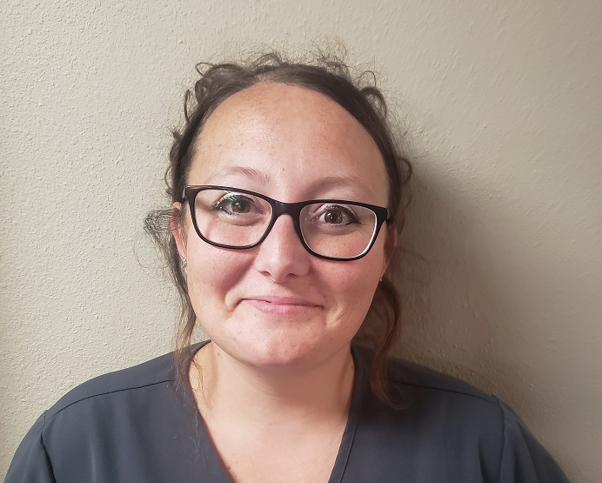
Contact Us
The Madison Senior Living
1702 41st Street
Fort Madison, IA 52627
319.372.8021
bwright@themadison.biz
www.themadison.biz

The Madison Senior Living
1702 41st Street
Fort Madison, IA 52627
Recipient Name
Street Address
City, ST ZIP Code

Forget ESPN, The Madison Senior Living has its own sports reporter. Don may be a little bias towards the Iowa Hawkeyes, Saint Louis Cardinals, and Kansas City Chiefs but one thing Don isn’t is a resident who doesn’t ever not greet you and have a conversation about sports. Besides being one of the nicest individuals you will ever meet, he is the most knowledgeable of Cardinals fans and will always have something to say about his Hawkeyes. His room is papered with sports pics, but the most valuable to him are the pictures he has displayed of his girls. Don is an MVP of The Madison and the Most Valuable Dad to his kids.

